Universidad Hispanoamericana
Proyecto Programado Teleproceso y Redes
Estudiante:
Alex Joan Roblero Quiros
Profesor:
Milton Emilio Vargas Jiménez
Teleproceso y Redes
Abril 2026

Contenido
Topología: 3
Configuraciones: 3
Router San José: 3
Show running: 3
Router Cartago: 10
Show running: 10
Switch San José: 16
Show running: 16
Show vlan brief: 24
Switch Cartago: 25
Show running: 25
Show vlan brief: 32
Tabla de IP: 33
Pruebas de Conectividad: 34
Prueba de conexión desde la PC - Administración (San José) hacia la PC - Profesores (Cartago) 34
Prueba de conexión desde la PC - Academia (San José) hacia la PC - Laboratorio (San José) 35
Prueba de búsqueda de la página web desde la PC - Estudiantes (Cartago) 36
Verificación de datos automáticos en la PC - Profesores (Cartago) 37

Topología:
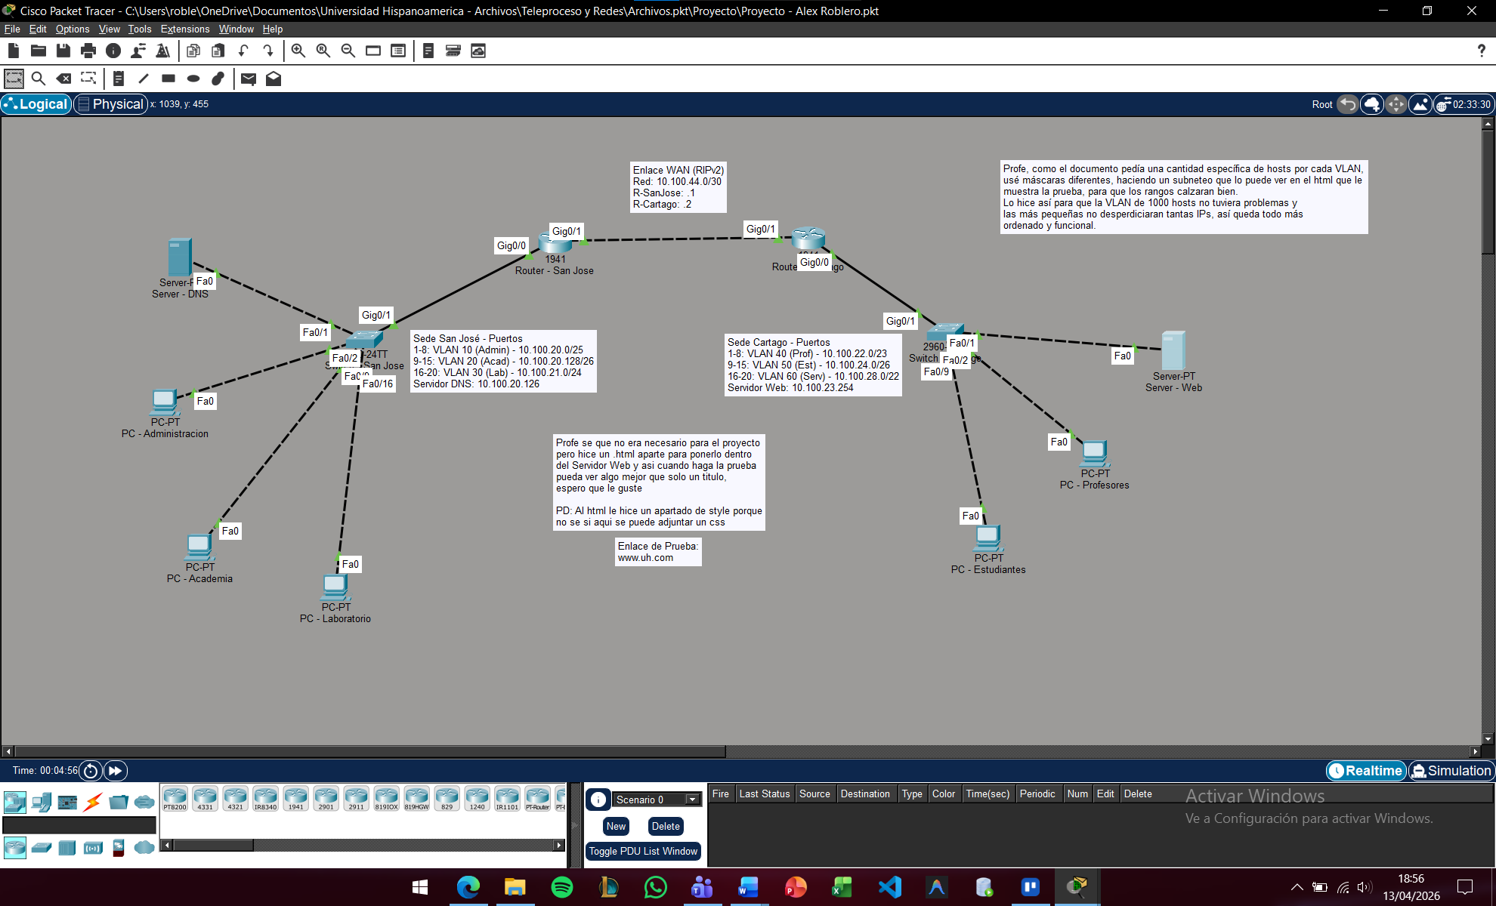

Configuraciones:

Router San José:

Show running:
R-SanJose#show running
Building configuration...

Current configuration : 1458 bytes
!
version 15.1
no service timestamps log datetime msec
no service timestamps debug datetime msec
no service password-encryption
!
hostname R-SanJose
!
!
!
!
ip dhcp excluded-address 10.100.20.1
ip dhcp excluded-address 10.100.20.126
ip dhcp excluded-address 10.100.20.129
ip dhcp excluded-address 10.100.21.1
!
ip dhcp pool vlan10
network 10.100.20.0 255.255.255.128
default-router 10.100.20.1
dns-server 10.100.20.126
ip dhcp pool vlan20
network 10.100.20.128 255.255.255.192
default-router 10.100.20.129
dns-server 10.100.20.126
ip dhcp pool vlan30
network 10.100.21.0 255.255.255.0
default-router 10.100.21.1
dns-server 10.100.20.126
!
!
!
ip cef
no ipv6 cef
!
!
!
!
license udi pid CISCO1941/K9 sn FTX1524JH93-
!
!
!
!
!
!
!
!
!
!
!
!
!
spanning-tree mode pvst
!
!
!
!
!
!
interface GigabitEthernet0/0
no ip address
duplex auto
speed auto
!
interface GigabitEthernet0/0.10
encapsulation dot1Q 10
ip address 10.100.20.1 255.255.255.128
!
interface GigabitEthernet0/0.20
encapsulation dot1Q 20
ip address 10.100.20.129 255.255.255.192
!
interface GigabitEthernet0/0.30
encapsulation dot1Q 30
ip address 10.100.21.1 255.255.255.0
!
interface GigabitEthernet0/1
ip address 10.100.44.1 255.255.252.0
duplex auto
speed auto
!
interface Vlan1
no ip address
shutdown
!
router rip
version 2
network 10.0.0.0
no auto-summary
!
ip classless
!
ip flow-export version 9
!
!
!
!
!
!
!
line con 0
!
line aux 0
!
line vty 0 4
login
!
!
!
end

Router Cartago:

Show running:
R-Cartago#show running
Building configuration...

Current configuration : 1446 bytes
!
version 15.1
no service timestamps log datetime msec
no service timestamps debug datetime msec
no service password-encryption
!
hostname R-Cartago
!
!
!
!
ip dhcp excluded-address 10.100.22.1
ip dhcp excluded-address 10.100.23.254
ip dhcp excluded-address 10.100.24.1
ip dhcp excluded-address 10.100.28.1
!
ip dhcp pool vlan40
network 10.100.22.0 255.255.254.0
default-router 10.100.22.1
dns-server 10.100.20.126
ip dhcp pool vlan50
network 10.100.24.0 255.255.255.192
default-router 10.100.24.1
dns-server 10.100.20.126
ip dhcp pool vlan60
network 10.100.28.0 255.255.252.0
default-router 10.100.28.1
dns-server 10.100.20.126
!
!
!
ip cef
no ipv6 cef
!
!
!
!
license udi pid CISCO1941/K9 sn FTX1524DTS6-
!
!
!
!
!
!
!
!
!
!
!
!
!
spanning-tree mode pvst
!
!
!
!
!
!
interface GigabitEthernet0/0
no ip address
duplex auto
speed auto
!
interface GigabitEthernet0/0.40
encapsulation dot1Q 40
ip address 10.100.22.1 255.255.254.0
!
interface GigabitEthernet0/0.50
encapsulation dot1Q 50
ip address 10.100.24.1 255.255.255.192
!
interface GigabitEthernet0/0.60
encapsulation dot1Q 60
ip address 10.100.28.1 255.255.252.0
!
interface GigabitEthernet0/1
ip address 10.100.44.2 255.255.252.0
duplex auto
speed auto
!
interface Vlan1
no ip address
shutdown
!
router rip
version 2
network 10.0.0.0
no auto-summary
!
ip classless
!
ip flow-export version 9
!
!
!
!
!
!
!
line con 0
!
line aux 0
!
line vty 0 4
login
!
!
!
end

Switch San José:

Show running:
Sw-SanJose#show running
Building configuration...

Current configuration : 2127 bytes
!
version 15.0
no service timestamps log datetime msec
no service timestamps debug datetime msec
no service password-encryption
!
hostname Sw-SanJose
!
!
!
!
!
!
spanning-tree mode pvst
spanning-tree extend system-id
!
interface FastEthernet0/1
switchport access vlan 10
switchport mode access
!
interface FastEthernet0/2
switchport access vlan 10
switchport mode access
!
interface FastEthernet0/3
switchport access vlan 10
switchport mode access
!
interface FastEthernet0/4
switchport access vlan 10
switchport mode access
!
interface FastEthernet0/5
switchport access vlan 10
switchport mode access
!
interface FastEthernet0/6
switchport access vlan 10
switchport mode access
!
interface FastEthernet0/7
switchport access vlan 10
switchport mode access
!
interface FastEthernet0/8
switchport access vlan 10
switchport mode access
!
interface FastEthernet0/9
switchport access vlan 20
switchport mode access
!
interface FastEthernet0/10
switchport access vlan 20
switchport mode access
!
interface FastEthernet0/11
switchport access vlan 20
switchport mode access
!
interface FastEthernet0/12
switchport access vlan 20
switchport mode access
!
interface FastEthernet0/13
switchport access vlan 20
switchport mode access
!
interface FastEthernet0/14
switchport access vlan 20
switchport mode access
!
interface FastEthernet0/15
switchport access vlan 20
switchport mode access
!
interface FastEthernet0/16
switchport access vlan 30
switchport mode access
!
interface FastEthernet0/17
switchport access vlan 30
switchport mode access
!
interface FastEthernet0/18
switchport access vlan 30
switchport mode access
!
interface FastEthernet0/19
switchport access vlan 30
switchport mode access
!
interface FastEthernet0/20
switchport access vlan 30
switchport mode access
!
interface FastEthernet0/21
!
interface FastEthernet0/22
!
interface FastEthernet0/23
!
interface FastEthernet0/24
!
interface GigabitEthernet0/1
switchport mode trunk
!
interface GigabitEthernet0/2
!
interface Vlan1
no ip address
shutdown
!
!
!
!
line con 0
!
line vty 0 4
login
line vty 5 15
login
!
!
!
!
End

Show vlan brief:
Sw-SanJose#show vlan brief

VLAN Name Status Ports
---- -------------------------------- --------- -------------------------------
1 default active Fa0/21, Fa0/22, Fa0/23, Fa0/24
Gig0/2
10 Administracion active Fa0/1, Fa0/2, Fa0/3, Fa0/4
Fa0/5, Fa0/6, Fa0/7, Fa0/8
20 Academicas active Fa0/9, Fa0/10, Fa0/11, Fa0/12
Fa0/13, Fa0/14, Fa0/15
30 Laboratorio active Fa0/16, Fa0/17, Fa0/18, Fa0/19
Fa0/20
1002 fddi-default active
1003 token-ring-default active
1004 fddinet-default active
1005 trnet-default active

Switch Cartago:

Show running:
Sw-Cartago#show running
Building configuration...

Current configuration : 2127 bytes
!
version 15.0
no service timestamps log datetime msec
no service timestamps debug datetime msec
no service password-encryption
!
hostname Sw-Cartago
!
!
!
!
!
!
spanning-tree mode pvst
spanning-tree extend system-id
!
interface FastEthernet0/1
switchport access vlan 40
switchport mode access
!
interface FastEthernet0/2
switchport access vlan 40
switchport mode access
!
interface FastEthernet0/3
switchport access vlan 40
switchport mode access
!
interface FastEthernet0/4
switchport access vlan 40
switchport mode access
!
interface FastEthernet0/5
switchport access vlan 40
switchport mode access
!
interface FastEthernet0/6
switchport access vlan 40
switchport mode access
!
interface FastEthernet0/7
switchport access vlan 40
switchport mode access
!
interface FastEthernet0/8
switchport access vlan 40
switchport mode access
!
interface FastEthernet0/9
switchport access vlan 50
switchport mode access
!
interface FastEthernet0/10
switchport access vlan 50
switchport mode access
!
interface FastEthernet0/11
switchport access vlan 50
switchport mode access
!
interface FastEthernet0/12
switchport access vlan 50
switchport mode access
!
interface FastEthernet0/13
switchport access vlan 50
switchport mode access
!
interface FastEthernet0/14
switchport access vlan 50
switchport mode access
!
interface FastEthernet0/15
switchport access vlan 50
switchport mode access
!
interface FastEthernet0/16
switchport access vlan 60
switchport mode access
!
interface FastEthernet0/17
switchport access vlan 60
switchport mode access
!
interface FastEthernet0/18
switchport access vlan 60
switchport mode access
!
interface FastEthernet0/19
switchport access vlan 60
switchport mode access
!
interface FastEthernet0/20
switchport access vlan 60
switchport mode access
!
interface FastEthernet0/21
!
interface FastEthernet0/22
!
interface FastEthernet0/23
!
interface FastEthernet0/24
!
interface GigabitEthernet0/1
switchport mode trunk
!
interface GigabitEthernet0/2
!
interface Vlan1
no ip address
shutdown
!
!
!
!
line con 0
!
line vty 0 4
login
line vty 5 15
login
!
!
!
!
end

Show vlan brief:
Sw-Cartago#show vlan brief

VLAN Name Status Ports
---- -------------------------------- --------- -------------------------------
1 default active Fa0/21, Fa0/22, Fa0/23, Fa0/24
Gig0/2
40 Profesores active Fa0/1, Fa0/2, Fa0/3, Fa0/4
Fa0/5, Fa0/6, Fa0/7, Fa0/8
50 Estudiantes active Fa0/9, Fa0/10, Fa0/11, Fa0/12
Fa0/13, Fa0/14, Fa0/15
60 Servicio active Fa0/16, Fa0/17, Fa0/18, Fa0/19
Fa0/20
1002 fddi-default active
1003 token-ring-default active
1004 fddinet-default active
1005 trnet-default active

Tabla de IP:
VLAN | Departamento | Hosts | Dirección de Red | Máscara de Subred | Gateway (Router IP)
10 | Administración | 100 | 10.100.20.0 | 255.255.255.128 | 10.100.20.1
20 | Académicas | 50 | 10.100.20.128 | 255.255.255.192 | 10.100.20.129
30 | Laboratorio | 250 | 10.100.21.0 | 255.255.255.0 | 10.100.21.1
40 | Profesores | 500 | 10.100.22.0 | 255.255.254.0 | 10.100.22.1
50 | Estudiantes | 60 | 10.100.24.0 | 255.255.255.192 | 10.100.24.1
60 | Servicio | 1000 | 10.100.28.0 | 255.255.252.0 | 10.100.28.1

Pruebas de Conectividad:
Prueba de conexión desde la PC - Administración (San José) hacia la PC - Profesores (Cartago)
Aquí estoy probando que los datos viajan sin problemas entre las dos sedes. Como se ve en el ping, la comunicación entre San José y Cartago funciona correctamente gracias a la ruta que configuré en los routers.
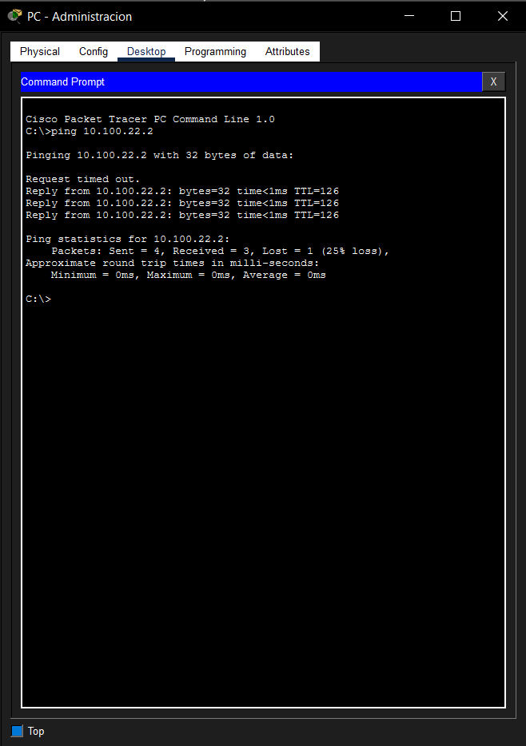

Prueba de conexión desde la PC - Academia (San José) hacia la PC - Laboratorio (San José)
Con este ping confirmo que los diferentes departamentos de la sede San José pueden hablarse entre ellos. Esto demuestra que el enrutamiento interno que hice en el router está trabajando bien.
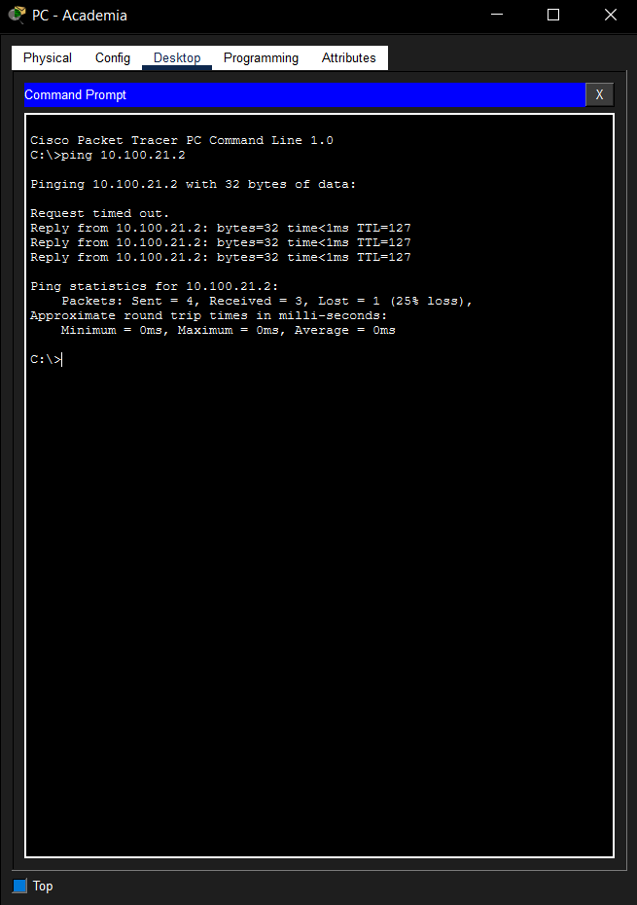

Prueba de búsqueda de la página web desde la PC - Estudiantes (Cartago)
En esta parte verifiqué que la computadora de los estudiantes puede encontrar el servidor de la universidad usando solo el nombre www.uh.com. Esto confirma que el servidor DNS está traduciendo la dirección correctamente.
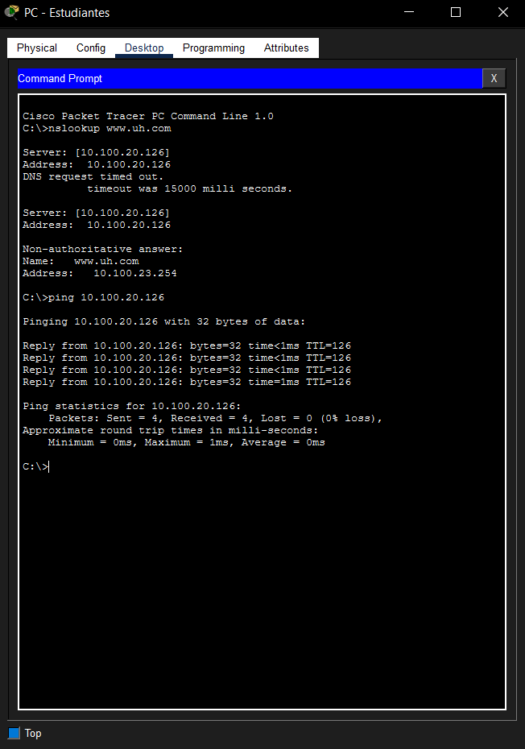

Verificación de datos automáticos en la PC - Profesores (Cartago)
Entré a la configuración de esta PC para asegurar que el sistema le asignó su dirección IP y el resto de los datos de forma automática. Como se ve en la captura, el DHCP le dio toda la información necesaria para navegar.
